

**Source: www.list25.com**

**Read about the dumbest criminals ever. Fill in the gaps with narrative tenses, active ot passive.**



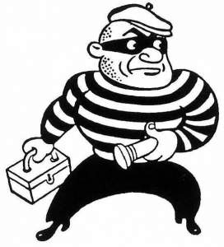



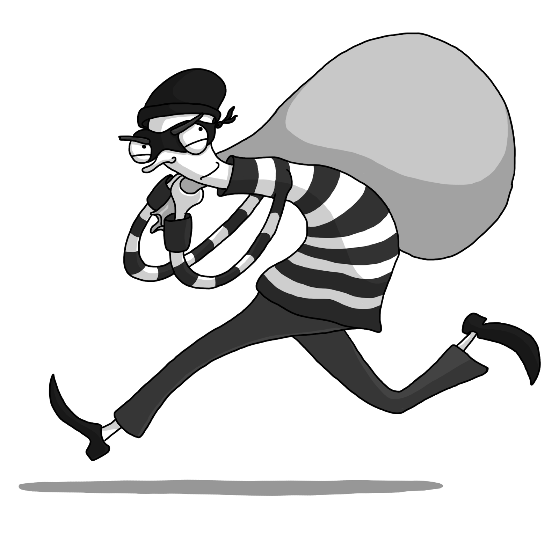

**Justin Stansfield, 38 a British heroin addict and thief, ______ (break into) a garage. He ________ (intend) to steal anything he could find of value so he could sell and buy some more drugs. While in the garage he _______ (find) a freezer full of cold beers so he decided to have some fun. Justin _______ (take out) his fake teeth to enjoy a couple of Popsicles which he ______________ (also discover) in the freezer. Unfortunately, before he left he forgot to put his teeth back in. Later this ______ (cost) him sixteen months behind bars**.

**Fort Myers Beach, Florida, can be proud of producing the worst, and possibly funniest, amateur American criminal who ever lived. Christopher Kron _______ (create) his own personal “legend” when he tried to rob a closed restaurant. First he tripped the alarm when he broke in; he didn’t listen to or just didn’t care about the NON-SILENT alarm; when ADT called the restaurant after receiving the alarm signal, Kron ________ (answer) the phone and, pay attention here, gave the ADT employee his real name; when he finally _____ (decide) to leave, all he took was a bottle of Grand Marnier and a beer.**

**So, you probably think that was the end of it, right? Well there’s more. Believe it or not, Kron managed to get away with his illegal act but made sure to return to the restaurant the next day where an employee who ______ (see) the surveillance video recognized him. Kron _______ (arrest) and if there were an award for the dumbest criminal in history, he would be a very serious contender.**

**A thief in Portland, Oregon, ______ (break into) a house, ________ (go through) every inch of the property, _______ (open) all the drawers, and ______(steal) everything of value he could find without leaving any fingerprints. However, what appeared to be almost the perfect robbery _________ (ruin) when the thief grabbed a container of orange juice from the refrigerator and took a gulp directly from it, leaving it in the sink. The container _______ (send) straight to the DNA testing unit at the Oregon State Crime Lab in Clackamas where forensic scientists found a match. Christopher Lathrop quickly confessed after he ______ (arrest) and will probably never drink orange juice again.**